***Mini Project Synopsis on***



## CAKE TOWN WITH RECOMMENDATION AND AI CHATBOT

**T.E. - I.T Engineering**

## Submitted By

**Aaswit Kanhed (20104083)**

**Pratham Bhagwat (20104095)**

**Kunal Palande (20104031)  
Nishant Palav (20104055)**

**Under The Guidance Of**

## Prof. Charul Singh

**DEPARTMENT OF INFORMATION TECHNOLOGY**

## A.P. SHAH INSTITUTE OF TECHNOLOGY

G.B. Road, Kasarvadavali, Thane (W), Mumbai-400615

UNIVERSITY OF MUMBAI

**Academic year: 2022-23**

## CERTIFICATE

This is to certify that the Mini Project report on **Cake Town with Recommendation and AI Chatbot** has been submitted by Aaswit Kanhed (20104083), Pratham Bhagwat (20104095), Kunal Palande (20104031), Nishant Palav (20104055) who are the students of A. P. Shah Institute of Technology, Thane, Mumbai, as a partial fulfilment of the requirement for the degree in Information Technology, during the academic year 2022-2023 in the satisfactory manner as per the curriculum laid down by University of Mumbai.

## Prof. Charul Singh

**Guide**

## Dr. Kiran Deshpande Dr. Uttam D. Kolekar

**Head of Department of Information Technology Principal**

### External Examiner(s): 1.

**2.**

**Place:** A.P Shah Institute of Technology, Thane

**Date:**

## ACKNOWLEDGEMENT

This project would not have come to fruition without the invaluable help of our guide **Prof. Charul Singh** Expressing gratitude towards our HoD**, Dr. Kiran Deshpande**, and the Department of Information Technology for providing us with the opportunity as well as the support required to pursue this project. We would also like to thank our teachers who gave us her valuable suggestions and ideas when we were in need of them. We would also like to thank our peers for their helpful suggestions.

**TABLE OF CONTENTS**

1. Introduction 6
   1. Purpose 7
   2. Objectives 7

1.2 Scope 8

1. Literature Review 9
2. Proposed System 10
   1. Problem Statement 10
   2. Features and Functionality 11
3. Requirements Analysis. 12
4. Project Design 14
   1. Use Case diagram 14
   2. DFD (Data Flow Diagram) 15
5. Technology Specifications 18
6. Project Scheduling 19
7. Result And Discussion… 20
8. Conclusion… 24

References 25

# Chapter No. 1

## INTRODUCTION

This project is a web based shopping system for an existing shop. The project objective is to deliver the online shopping application into android platform. This project is an attempt to provide the advantages of online shopping to customers of a real shop. It helps buying the products in the shop anywhere through internet by using an android device. Thus, the customer will get the service of online shopping and home delivery from his favorite shop. This system can be implemented to any shop in the locality or to multinational branded shops having retail outlet chains. If shops are providing an online portal where their customers can enjoy easy shopping from anywhere, the shops won’t be losing any more customers to the trending online shops such as flipcart or ebay. Since the application is available in the Smartphone, Computers and other connectivity devices, it is easily accessible and always available.

Online shopping is the process whereby consumers directly buy goods or services from a seller in real-time, without an intermediary service, over the Internet. It is a form of electronic commerce. This project is an attempt to provide the advantages of online shopping to customers of a real shop. It helps buying the products in the shop anywhere through internet by using an android device. Thus, the customer will get the service of online shopping and home delivery from his favorite shop.

This gifting website is implemented using HTML, CSS, JavaScript programming language. This project is advanced method of selling gifts through online application. As in present trend online shopping has become a best place for buying products. This application works on the principle, users need to register with website and select products from categories and add product to chart and buy product by selection online payment, payment on delivery, etc.

### Purpose:

To manage Online Gift Shopping purposefully and efficiently. It helps customers to search for and buy gifts from anywhere. Also, make payment on delivery for it. It helps people to book a desired gift at their preference time and place. To make available a huge online marketplace to all the cake shop and gift shop owners.

### Objectives:

* To build user friendly interface :- Our website User Interface enhance the customers shopping experience with the help of our efficient and effective platform because of which they will prefer to shop form our online website instead of going to shops.
* To Customize your own cake :- To provide a special feature of designing your own cake with the help of our website. With the help of this feature on online mode we can reach to maximum customers and increase the businesses of the shop owners.
* To provide variety of gift on a single platform :- Our website make the work of customers easy by providing variety of gifts on a single platform with different categories.
* To build various Payment Methods :- To make a payment portal and provide different types of payment methods like Gpay, Phonepay, UPI, Credit Card, Debit Card, Internet Banking, Cash on delivery, etc for the customers to make payment easy and convenient.
  1. **Scope :**
* A Gift Shopping system is huge and important, but it can be used by small and large businesses like,as the main aim to provide effective customer service.
* To add a user friendly chatbot which will resolve users doubts from various frequently asked questions.
* It would be much more comfortable for the customers to have an online gift order. It would be hassle free for users as they can select the gifts they want and make payment for it. Also, it will reduce the purchasing time for customers.
* This system can be implemented to any shop in the locality or to multinational branded shops having retail outlet chains. The system recommends a facility to accept the orders 24*7 and a home delivery system which can make customers happy.
* If Gift shops are providing an online portal where their customers can enjoy easy gift shopping from anywhere, the shops won’t be losing any more customers to the trending online shops. Since the application is available in the Smartphone it is easily accessible and always avail

# Chapter No. 2

## Literature Review

Senthil Kumar K and Sakthi Kumaran M published the “E-Gift Shop Application” in “Interactive Technology and Smart Education” conferrence on 2020 and according to them the major advantages of their system is Flexibility, Time Management, Skill Development, Wider global reach, they used following techstack php, laravel, aws ec 2 , react, bootstrap and graphql. According to their system, Private customers can have a payment option through credit card only. In order to use the load writing procedure, the customers registers itself and receives a login for its purchase name. It is an internet application. Login functionality should check the authenticity of the user from the database. This site contains an online catalog for the user. From this publication we concluded to use their robust tech stack as it provide scalabilty that is php and mysql.

Chengfeng Xue and Xiting Zeng published the “Business Process Re-engineering to Support Cake Shop Business Sustainability” in “Alifio Ibnu Nugroho” conferrence on 2014 and according to them, The cake shop has been around since 2000, but previously in 1999 they had tried to process the cake shop's recipe so that they found a concoction that suited the local people's tongue. However, this business did not last long because the shop they owned had experienced a fire incident which caused the cake shop business to be evicted and eventually moved to another place so that they also received business threats, namely the emergence of many competitors selling similar products. The purpose of our research is that we will conduct a re-engineering analysis to optimize the business processes in the cake shop. The research method used in our research is descriptive. The descriptive research method is carried out by seeking information related to existing symptoms, clearly explaining what goals will be achieved in the research conducted. In this new model, we add a promotion method, namely by using advertising services on social media so that it can reach people who are still not familiar with the product. In the new model, we also added a process, namely a research process to add innovation to new product cake variants that will give a new impression to the shop's customers. From this publication we concluded how to improve online reach by social media to increase website popularity.

# Chapter No. 3

## PROBLEM STATEMENT:

As Online Gift shopping website became a trend nowadays the regular shops are losing their customers to online brands. Customers have effortless shopping experience and saving time through shopping online. For competing with those online brands, If shops are providing an online portal where their customers can shop through internet and get the gifts at their doors it will increase the number of customers.

## PROPOSED SYSTEM

In the proposed system customer need not go to the shop for buying the products. He can order the gift products he wish to buy through the application in his Smartphone/Other devices. The shop owner will be admin of the system. Shop owner can appoint moderators who will help owner in managing the customers and product orders. The payment method contains various modes. The system also recommends a home delivery system for the purchased products.

## Block Diagram:

Step 1:- Login page And Register Page- user need to register if not already register or login directly usling the credentials

Step 2:- Home Page- After logging in user will come on home page of our website.

Step 3:- Product Categories:- There are different types of gifts available like cakes, idols, antique pieces, flowers, mugs.

Step 4:- About Us and Contact us page:- There is information about our website in about us and users can contact us about any of the problem using contact page.

Step 5:- Cart- After selecting a product it is added in the cart where user can go and buy the product by clicking on order now button.

### Features & Functionality:

* + - Users can search for products from the search bar.
    - This system helps customers to place orders through online also eases the workload on the staff of gift shop.
    - This system will make things easier for staff as whole ordering process is done by customer only.
    - As most of the things will be performed online, it will reduce the usage of paper for the gift shop.
    - Online Gift Shopping website is a web-based application which enables customers to order gift items through online for home delivery or pick up from the shop.
    - This system will help customers in ordering custom gifts. So, the customer will pick exactly the things which he/she wants in their gifts.
    - This system will provide customer all the details of his order before hand after confirmation which will help them to check the items and their prices and other information.
    - This system will give option to the customers for online payment and cash on delivery as well.

# Chapter No. 4

## REQUIREMENT ANALYSIS

### Importance of Requirements Gathering:

Requirements gathering is a fundamental part of any business decision. It helps generate a list of system, functional and technical requirements from the different stakeholders involved in the process. Being confident about what requirements to look for ensures your expectations with the deliverables are clear, and that eventually enables you to make the right choice when it comes to selecting a Gift Shopping solution for your business. No one knows your business better than us. So, it’s important to figure out your expectations from the platform before you start looking for one the requirements. Once we know what we want the software to do for our project, so it becomes way easier to pick solutions that line up with your needs.

### Need Analysis:

What goals are you trying to accomplish?

Not all Gift shopping systems are built equal. Some cater to small businesses while others are much more suitable for large enterprises. Vendors offer a wide range of functionality, and with thatcomes varying levels of complexity.

What size is your Gift shop business?

The idea was to work with young people to enable them to set up their own shop, make their own products and to sell them to their local community. The Shop aimed to introduce young people to the idea of ‘Gift

Giving’ and to the work of 42nd Street with any money raised from this venture to be re-invested into local activity. Further, it provided the opportunity for a diverse range of people from the local community to come together and appreciate the talents, time and efforts of young people who are often viewed as troublesome.

### Key Requirements:

Through extensive experience and research, we’ve compiled a comprehensive shopping system evaluation checklist of the most critical gift requirements to look for when researching and comparing vendors for your business. These requirements are the most common for the average company, but some may not be applicable to everyone. Different online shopping systems focuson different capabilities, so it’s vital to know what functionality your customers requires viaa Gift shopping website.

# Chapter No: 5

## PROJECT DESIGN

* + - * Use Case Diagram

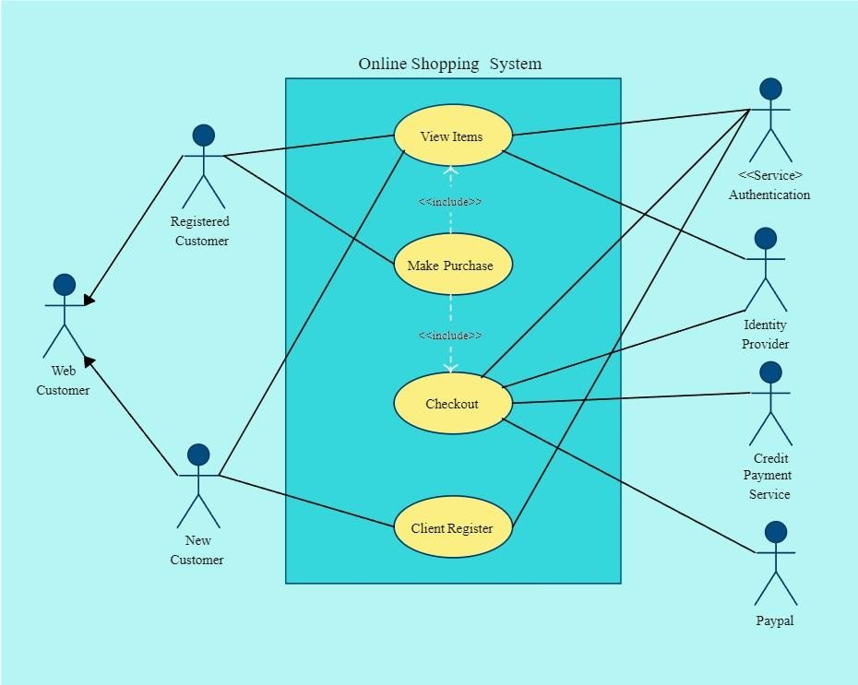

### Figure 1: Use Case Diagram

* + - * DFD (Data Flow Diagram) Diagram:

Gift Management



Gift Shopping

System

Customer Management

Sales Management

Stock Management

Gift Types Management

Inventory Management

### Figure 2: DFD (Level 0)

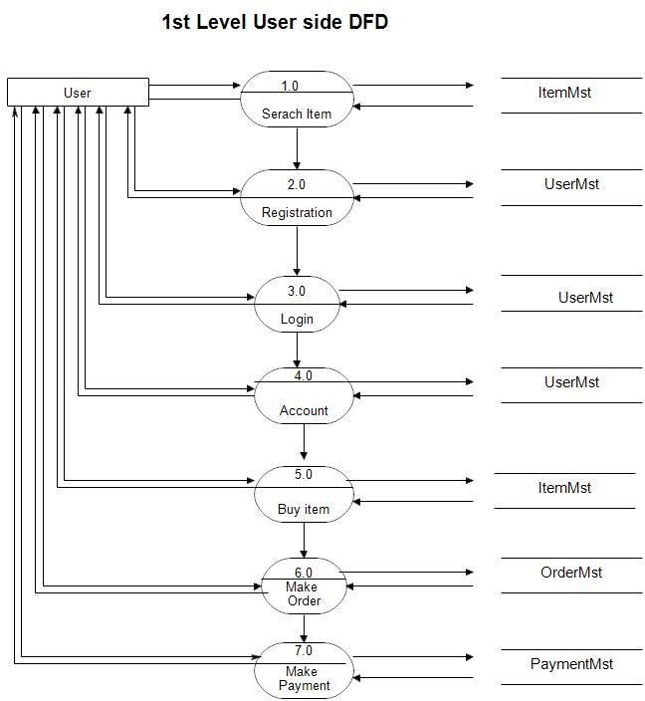

**Figure 3: DFD (Level 1)**

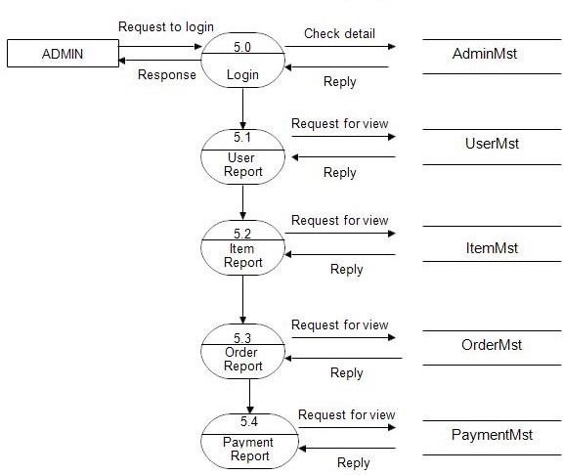

**Figure 4: DFD (Level 2)**

# Chapter No. 6

## TECHNOLOGY SPECIFICATIONS

#### Development Environment: VS Code

VS Code also known as Visual Studio Code is a source code editor made by Microsoft for Windows, Linux, MacOS. It has various features such as Debugging, Syntax highlighting, extension, intelligent code completion.

#### Frontend: Html, CSS, JavaScript

HTML (Hyper Text Markup Language): HTML is a syntax used to format a text document on the web.

CSS (Cascading Style Sheets): CSS is a style sheet language used for describing the look and formatting of a document written in a markup language.

Java Script: JS is a dynamic computer programming language. It is most commonly used as part of web browsers, whose implementations allow client-side Online Shopping System Department of Computer Science, CUSAT Page 37 scripts to interact with the user, control the browser, communicate asynchronously, and alter the document content that is displayed.

#### Operating System (OS): Windows

Windows is a graphical operating system developed by Microsoft. It allows users to view and store files, run the software, play games, watch videos, and provides a way to connect to the internet. It was released for both home computing and professional works.

#### Database (DB): phpMyAdmin

phpMyAdmin is a free software tool written in PHP, intended to handle the administration of MySQL over the Web. It is the most popular application for MySQL database management. We can create, update, drop, alter, delete, import, and export MySQL database tables by using this software.

# Chapter No. 7

**PROJECT SCHEDULING**

|  |  |  |  |
| --- | --- | --- | --- |
| **Sr. No** | **Group Member** | **Time duration** | **Work to be done** |
| **1** | Pratham Bhagwat And  Aaswit Kanhed | 1st week of July | Implementing 1st module/ functionality |
| 2nd week of July | Testing 1st module |
| **2** | Kunal Palande and  Nishant Palav | 3rd week of August | Implementing 2nd module/ functionality |
| **3** | Aaswit Kanhed  Pratham Bhagwat Kunal Palande | 1st week of September | Implementing 3rd module/ functionality |

# Chapter No. 8

**Result And Discussion**

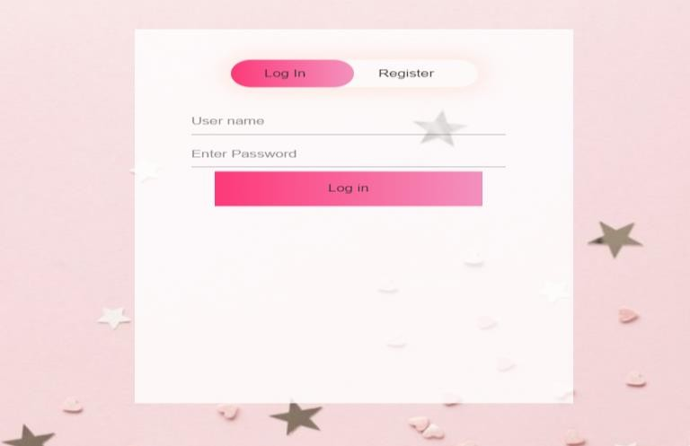

# Login And Register Page

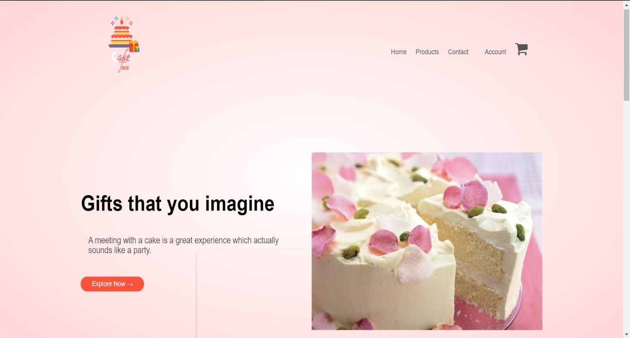

**Home Page**

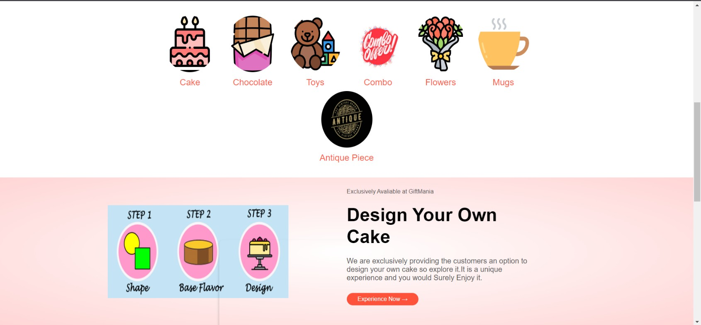

# Categories and Cake Customization

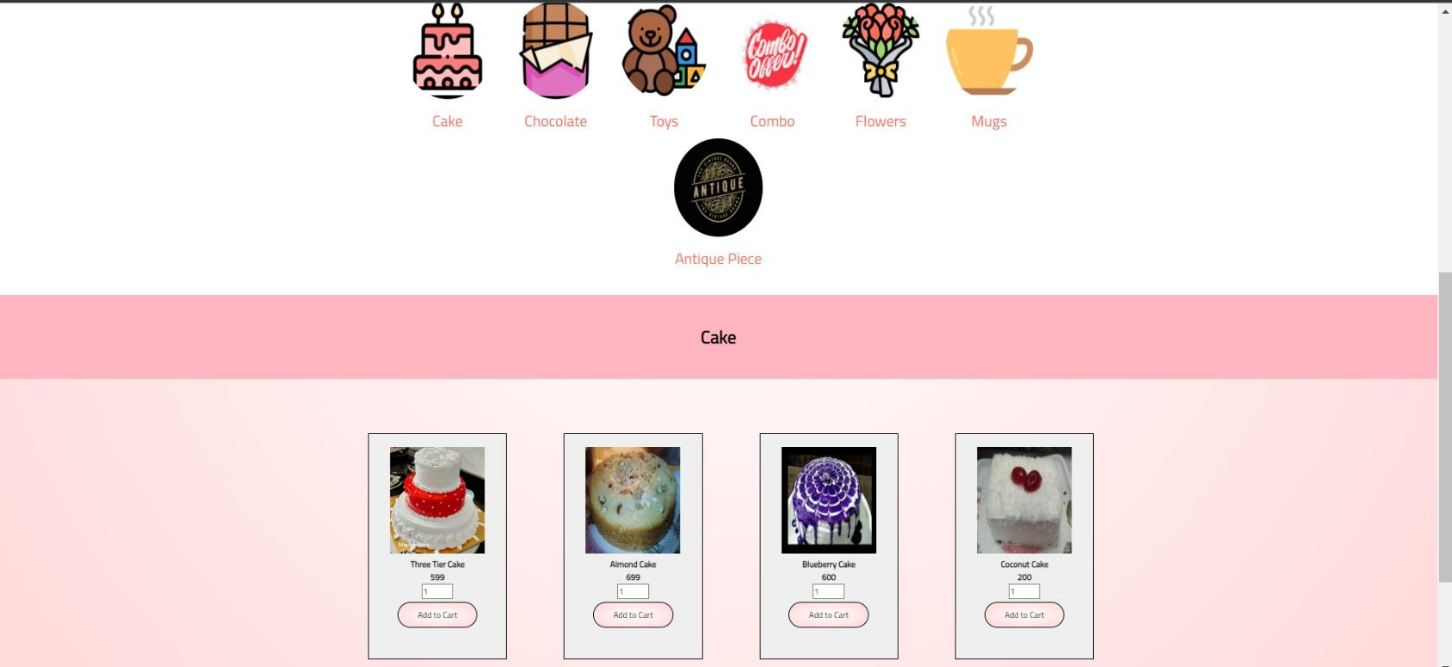

**Products**

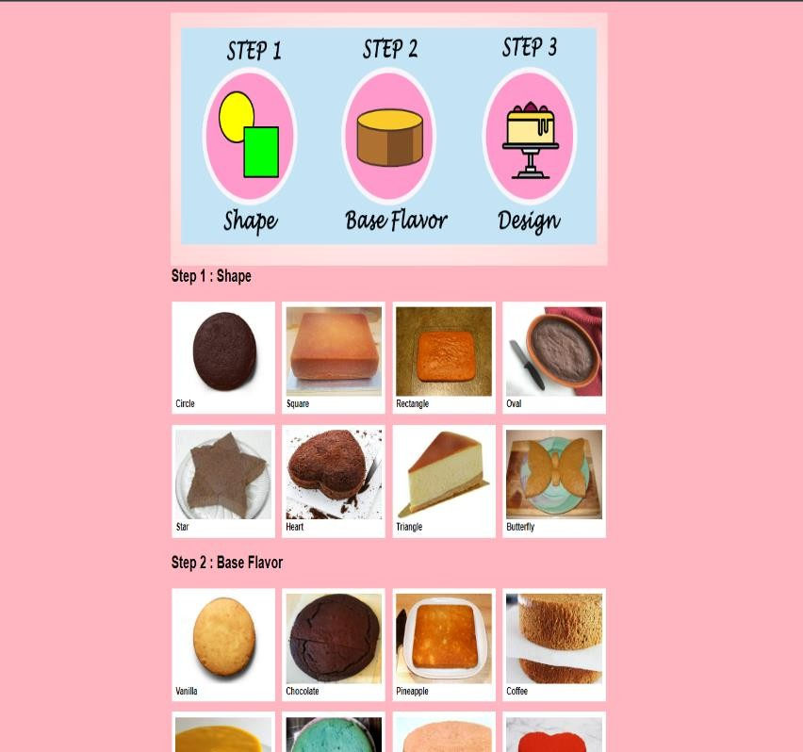 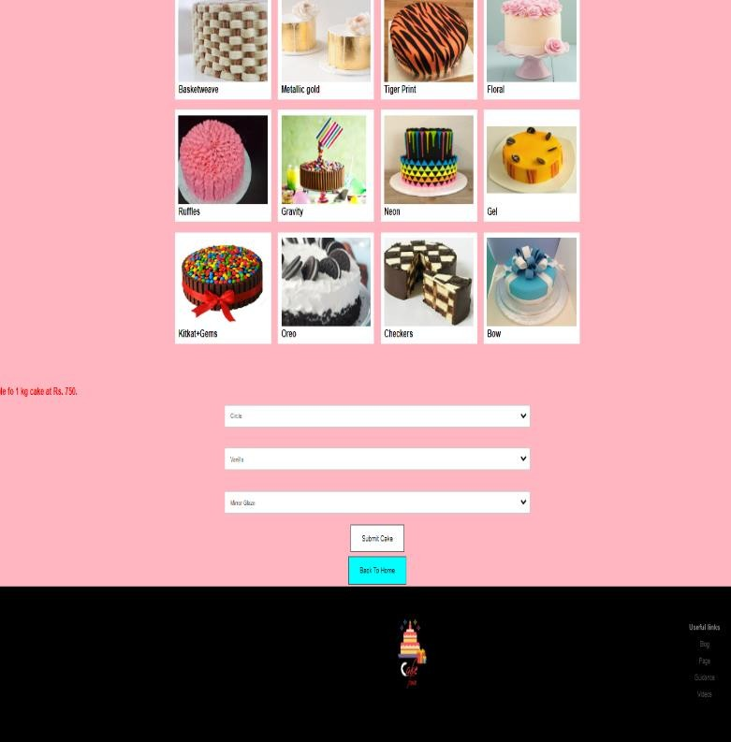

# Customization Page

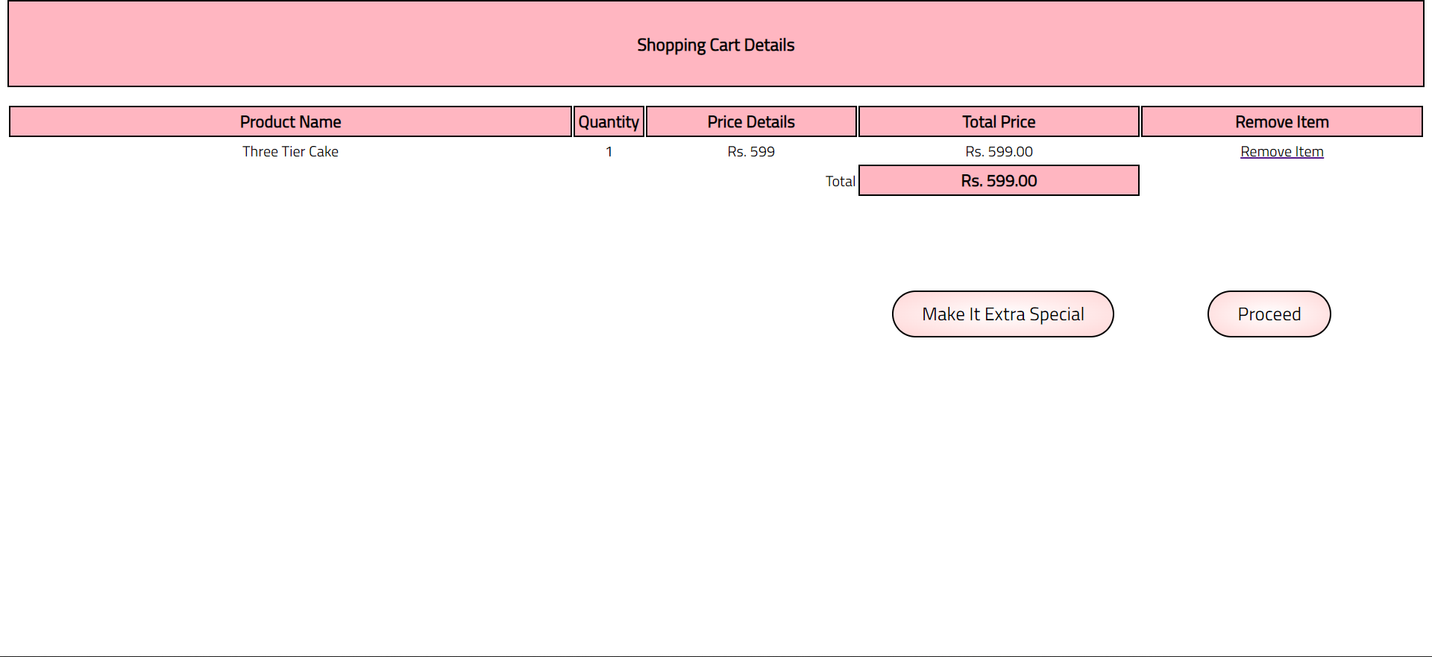

**Cart**

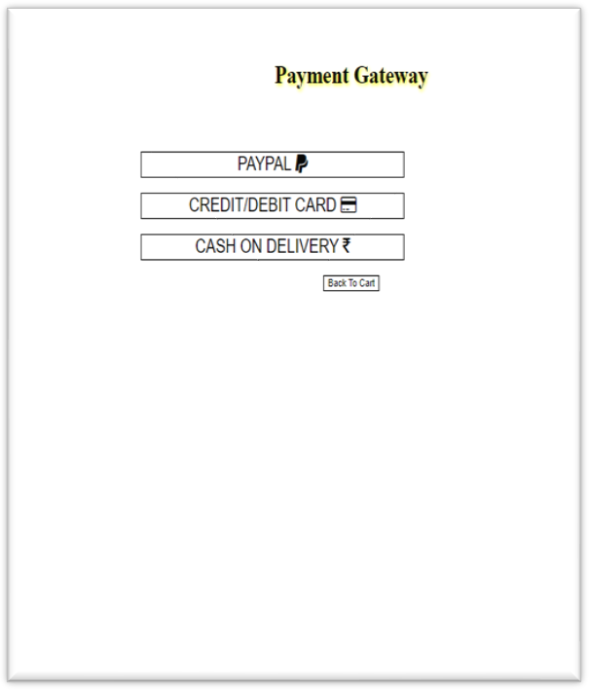 

# Payment Gateway And Portal

**Chapter No. 9**

**Conclusion**

Online Gift shopping website project is developed in HTML, CSS, JavaScript. The main aim of this system is to implement an online buying and selling of the cake and gift products which is helpful for customers as well as the shop owners. Online Shopping is one of the quick growing fields on internet wherever users will directly shop by visiting website. This method had inflated scope of online buying and selling. In conjunction with this online shopping our website also provides verities of gifting products. Also, with new and special feature of cake customization. Our system also provides different payment methods.

## REFERENCES

1. JavaScript Enlightenment, Cody Lindley-First Edition, based on JavaScript 1.5, ECMA-262, Edition
2. Mc GrawHill’s, Java: The complete reference 7thEdition, Herbert Schildit
3. Complete CSS Guide, Maxine Sherrin and John Allsopp-O'Reilly Media; September 2012
4. [http://www.w3schools.com/html/defualt.asp,](http://www.w3schools.com/html/defualt.asp) [http://www.w3schools.com/css/default.asp,](http://www.w3schools.com/css/default.asp) <http://www.w3schools.com/js/default.asp>